CAMPUSPULSE
Semantic Campus Recruitment & Placement System

Mini Project Report

Submitted by

Abey Mathew
Reg. No.: AJC22MCA-I002

In Partial fulfillment for the Award of the Degree of
INTEGRATED MASTER OF COMPUTER APPLICATIONS

(INMCA)

APJ ABDUL KALAM TECHNOLOGICAL UNIVERSITY


AMAL JYOTHI COLLEGE OF ENGINEERING AUTONOMOUS
KANJIRAPPALLY

[Affiliated to APJ Abdul Kalam Technological University, Kerala. Approved by AICTE, Accredited by NAAC. Koovappally, Kanjirappally, Kottayam, Kerala – 686518]

2026-2027

DEPARTMENT OF COMPUTER APPLICATIONS

AMAL JYOTHI COLLEGE OF ENGINEERING AUTONOMOUS
KANJIRAPPALLY


CERTIFICATE

This is to certify that the Project report, “CAMPUSPULSE” is the bona fide work of ABEY MATHEW (Regno: AJC22MCA-I002) carried out in partial fulfillment of the requirements for the award of the Degree of Integrated Master of Computer Applications at Amal Jyothi College of Engineering Autonomous, Kanjirappally, Affiliated to APJ Abdul Kalam Technological University. The project was undertaken during the period from July 01, 2026 to October 23, 2026.

Ms. Susmin Mariam Chacko Ms. Meera Rose Mathew

Internal Guide Coordinator

Dr. Bijimol T.K

Head of the Department

DECLARATION

I hereby declare that the project report “CAMPUSPULSE” is a bona fide work done at Amal Jyothi College of Engineering Autonomous, Kanjirappally, Affiliated to APJ Abdul Kalam Technological University, towards the partial fulfilment of the requirements for the award of the Integrated Master of Computer Applications (INMCA) during the period from July 01, 2026 to October 30, 2026.

Date: ABEY MATHEW

KANJIRAPPALLY Reg: AJC22MCA-I002

ACKNOWLEDGEMENT

First and foremost, I thank God almighty for his eternal love and protection throughout the project. I take this opportunity to express my gratitude to all who helped me in completing this project successfully. It has been said that gratitude is the memory of the heart. I wish to express my sincere gratitude to our Director (Administration) Rev. Fr. Dr. Roy Abraham Pazhayaparampil and Principal Dr. Lillykutty Jacob for providing good faculty for guidance.

I owe a great depth of gratitude towards our Head of the Department Dr. Bijimol T.K for helping us. I extend my whole hearted thanks to the project coordinator Ms. Meera Rose Mathew for her valuable suggestions and for overwhelming concern and guidance from the beginning to the end of the project. I would also express sincere gratitude to my guide Ms. Susmin Mariam Chacko for his inspiration and helping hand.

I thank our beloved teachers for their cooperation and suggestions that helped me throughout the project. I express my thanks to all my friends and classmates for their interest, dedication, and encouragement shown towards the project. I convey my hearty thanks to my family for the moral support, suggestions, and encouragement to make this venture a success.

ABEY MATHEW

ABSTRACT

CampusPulse is a digital solution to automate the campus placement and recruitment process with the integration of AI driven intelligence, transparency and efficiency at college recruitment drive. It intends to replace manual spreadsheets and email-based coordination with an intelligent online mechanism where students, recruiters and TPO (Training & Placement Officer) can get benefitted from easy-to-use interface that provides accessibility, removes conflict issues and gives fairness. The CampusPulse has a various module functioning each as a different system which caters all the need for the placement.
The Authentication module allows authentication using the role-based authentication using Students, Recruiters and TPOs by using a JWT based encryption along with a session management to secure the data using the authentication and authentication in the backend.
The Students module allows the pre-created student login, student can access and modify academic details, load their resume which can be used for the AI matchmaking (also have access to the explanations using XAI), access details based on the student eligible criteria (as a personalized jobs list for students), Apply for the job in single click, and the status of their applications will be trackable (applied, aptitude, GD, interview, offer accepted) at real-time with AI explained predictions.
The Recruiter module allows company recruiters register their company in the system, fill their information, POST job drives with eligibility criteria (mentioned CTC, CGPA, branches backlogs) and multiple stages of recruitment pipeline stages, match student resume with jobs, get intelligent screening, accept or reject and schedule the aptitude test, gd and interview with conflict free arrangement. The offer can be made manually or via bulk uploads and also the offer acceptance rate for individual job can be assessed and can check overall data with different graphs and charts using different AI tools.
The TPO module allows TPO to manage students via bulk CSV uploads, manage new recruiters, give all kind of permissions, review candidate applications manually also for any overridden or scheduling a separate slot. This module generates complete placement report as both CSV/PDF, provides advanced analysis and statistics like number of students placed, averageCTC, etc. It also checks for recruiter with its Trust Score (by performing WHOIS check and comparing the business details) to increase more trust to recruiters profile.
The AI Engine Module will perform sentence embedding on both Student resume and Jobs description with a model known as Sentence-BERT, to generate embeddings for each sentence and calculate the cosine similarity, 0 to 100% of similarity, between the job and student resume based on the actual capability of a student not based on keyword based. It also includes the XAIModule to explain the student that why he gets that particular match score against any of the jobs available in the dashboard and gives a detailed breakdown of skill gaps using those results and can improve better. It also includes the conflict-free Scheduling Engine which check for students and recruiter, and ensures no double-booking when scheduling interviews, gd, aptitude test or interviews. This scheduling is done by using MongoDB Compound indexes { studentId: 1, date: 1, timeSlot: 1 } this ensures data accuracy for students scheduled time for all possible stages of interview.
The Security Module covers all the points for making the whole system extremely safe and secure. It uses JWT token for authentication, password is hashed with bcrypt, and roles based authorization is used. All sensitive files and data are stored using MongoDB GridFS for better security.
The Commuication Module to provide real time chat and announcement of all jobs and interview to the students, which can be delivered using socket. IO, apart from all these there is PWA which helps the students get the interview schedule details even with offline access and many more features which can support students through entire journey in their CampusPulse.

CONTENT

SL. NO | TOPIC | PAGE NO
1 | INTRODUCTION | 1
1.1 | PROJECT OVERVIEW | 2
1.2 | PROJECT SPECIFICATION | 3-4
2 | SYSTEM STUDY | 5
2.1 | INTRODUCTION | 6
2.2 | EXISTING SYSTEM | 6
2.3 | DRAWBACKS OF EXISTING SYSTEM | 6
2.4 | PROPOSED SYSTEM | 6-7
2.5 | ADVANTAGES OF PROPOSED SYSTEM | 7-8
3 | REQUIREMENT ANALYSIS | 9
3.1 | FEASIBILITY STUDY | 10-11
3.1.1 | ECONOMICAL FEASIBILITY | 11-12
3.1.2 | TECHNICAL FEASIBILITY
3.1.3 | BEHAVIORAL FEASIBILITY
3.1.4 | FEASIBILITY STUDY QUESTIONNAIRE
3.2 | SYSTEM SPECIFICATION
3.2.1 | HARDWARE SPECIFICATION
3.2.2 | SOFTWARE SPECIFICATION
3.3 | SOFTWARE DESCRIPTION
3.3.1 | PHP
3.3.2 | MYSQL
4 | SYSTEM DESIGN
4.1 | INTRODUCTION
4.2 | UML DIAGRAM
4.2.1 | USE CASE DIAGRAM
4.2.2 | SEQUENCE DIAGRAM
4.2.3 | STATE CHART DIAGRAM
4.2.4 | ACTIVITY DIAGRAM
4.2.5 | CLASS DIAGRAM
4.2.6 | OBJECT DIAGRAM
4.2.7 | COMPONENT DIAGRAM
4.2.8 | DEPLOYMENT DIAGRAM
4.2.9 | COLLABORATION DIAGRAM
4.3 | USER INTERFACE DESIGN USING FIGMA
4.4 | DATABASE DESIGN
5 | SYSTEM TESTING
5.1 | INTRODUCTION
5.2 | TEST PLAN
5.2.1 | UNIT TESTING
5.2.2 | INTEGRATION TESTING
5.2.3 | VALIDATION TESTING
5.2.4 | USER ACCEPTANCE TESTING
5.2.5 | AUTOMATION TESTING
5.2.6 | SELENIUM TESTING
6 | IMPLEMENTATION
6.1 | INTRODUCTION
6.2 | IMPLEMENTATION PROCEDURE
6.2.1 | USER TRAINING
6.2.2 | TRAINING ON APPLICATION SOFTWARE
6.2.3 | SYSTEM MAINTENANCE
7 | CONCLUSION & FUTURE SCOPE
7.1 | CONCLUSION
7.2 | FUTURE SCOPE
8 | BIBLIOGRAPHY
9 | APPENDIX
9.1 | SAMPLE CODE
9.2 | SCREEN SHOTS

List of Abbreviations

CHAPTER 1

INTRODUCTION

PROJECT OVERVIEW
The BharatV Election Voting System is an innovative web-based platform designed to modernize Panchayat elections by digitizing key processes such as voter registration, candidate application, vote casting, and result generation. With a strong emphasis on security, transparency, and accessibility, the system integrates email verification to authenticate users and a session-based login system to ensure data integrity. The candidate dashboard offers a user-friendly interface with a modern green and orange theme, providing seamless navigation and dynamic content loading. Candidates can easily apply for elections, with the system fetching ward-specific elections dynamically from the database. The election management module allows administrators to oversee candidate approvals and ensure smooth election operations. Additionally, the profile management feature enables users to update their information and upload profile photos, further enhancing user experience. Overall, BharatV is a well-structured and efficient digital election system, leveraging PHP, MySQL, and JavaScript to ensure a secure, fair, and efficient electoral process.

Technology Stack
- Frontend: JavaScript, HTML, CSS
- Backend: PHP
- Database: MySQL
- Security Measures: Email verification, session-based authentication

Future Enhancements
- Automated Election Results: Implement real-time vote counting.
- Blockchain Integration: Improve election security and transparency.
- Scalability: Enhance performance to support nationwide elections.

PROJECT SPECIFICATION

1. Project Title

BharatV – A Secure and Dynamic Digital Voting Platform

2. Project Description

BharatV is an online voting system designed to facilitate secure, transparent, and efficient elections. The platform allows candidates to register and apply for elections dynamically, while voters can participate in elections based on their ward. It includes a Party Dashboard and a Returning Officer Dashboard to manage candidate approvals. The system ensures security through email verification and supports profile management with profile photos.

3. Functional Requirements

User Registration & Authentication

Users sign up with their email and receive a verification link.

Secure login with session-based authentication.

Candidate Dashboard

A sidebar-based UI for easy navigation.

Dynamically loaded candidate application form in candidate.php.

Candidates can view elections specific to their ward, fetched from the elections table.

Party Dashboard

Candidates contesting under a party submit applications to their selected party.

The party reviews and approves the candidate’s application.

Approved candidates' applications are sent to the Returning Officer Dashboard for final approval.

Returning Officer Dashboard

Receives candidate applications from both party-approved candidates and independent candidates.

Independent candidates submit applications directly to the Returning Officer (bypassing party approval).

The Returning Officer reviews applications and grants final approval.

Once approved, the candidate is officially registered for the election.

Voter Dashboard

Voters can view upcoming elections based on their ward.

Ability to cast votes securely.

Election Management

The system fetches and displays elections dynamically from the elections table.

Admins manage elections, verify candidates, and approve applications.

Profile Management

Users can upload and update their profile photo and other details stored in the users table.

Update personal information and settings.

4. Non-Functional Requirements

Security: Email verification, encrypted passwords, session management.

Scalability: Capable of handling large numbers of voters and candidates.

User-Friendly UI: Modern green and orange themed interface.

Performance Optimization: Efficient database queries for fast data retrieval.

CHAPTER 2

SYSTEM STUDY

INTRODUCTION

BharatV is a digital voting platform designed to modernize and streamline the election process. The system allows candidates to register, apply for elections, and receive approvals through a structured process involving Party and Returning Officer Dashboards. Voters can securely participate in elections relevant to their ward, ensuring a fair and transparent voting experience. The system addresses key challenges in traditional election management, including inefficiencies, security risks, and manual verification processes.

EXISTING SYSTEM

Traditional election nomination processes are manual and time-consuming, requiring candidates to submit physical documents, undergo verification, and wait for approvals. This process often results in delays, mismanagement, and lack of transparency.
2.2.1 NATURAL SYSTEM STUDIED

The traditional election system follows a manual approach, where candidates file physical applications, and approvals are conducted through paperwork. Election officers handle approvals manually, and voters physically visit polling stations to cast their votes. This system requires significant human intervention, making it prone to delays, errors, and security risks.
2.2.2 DESIGNED SYSTEM STUDIED
Some existing digital voting systems allow limited automation of voter registration and election management. However, many of these systems lack multi-level candidate approvals (party-level and returning officer-level verification) and fail to provide real-time election updates. Additionally, many current digital voting platforms suffer from poor scalability, weak security protocols, and lack of transparency.

DRAWBACKS OF EXISTING SYSTEM
- Manual Processes – Traditional elections involve excessive paperwork, increasing the risk of errors and delays.
- Lack of Transparency – Verifications and approvals are not always visible to all stakeholders, raising concerns over fairness.
- Time-Consuming Approvals – The approval process for candidates is slow, leading to inefficiencies
- Security Risks – Existing systems are vulnerable to fraud, manipulation, and unauthorized access.
- Limited Accessibility – Voters must be physically present at polling stations, restricting participation.
- No Centralized Candidate Management – Party-level and returning officer-level approvals are not well-integrated.
- Difficult Voter Verification – Ensuring voter identity remains a challenge without a robust verification mechanism.

PROPOSED SYSTEM

BharatV is a secure, digital election management platform that overcomes the limitations of the existing system. The proposed system introduces:

Candidate Registration & Verification: Candidates submit applications online, and approvals are handled efficiently via the Party and Returning Officer Dashboards.

Party Dashboard: Candidates contesting under a party submit applications for party approval before moving to the Returning Officer.

Returning Officer Dashboard: Final approval is granted here, ensuring only verified candidates are registered for elections.

Independent Candidate Workflow: Independent candidates can apply directly to the Returning Officer, skipping party-level approvals.

Voter Dashboard: Users can view elections based on their ward and participate securely.

Email Verification & Profile Management: Ensuring user authenticity with email-based verification and profile updates.

Modern UI with Dynamic Content Loading: A green and orange-themed interface with easy navigation for candidates, parties, and voters.

ADVANTAGES OF PROPOSED SYSTEM
- Fully Digital & Automated – Eliminates manual paperwork, making the election process faster and more efficient.
- Transparent Approval Process – Candidates and election officials can track the approval process at each level.
- Multi-Level Verification – Ensures only eligible candidates are approved through party and returning officer validations.
- Enhanced Security – Email verification, session-based authentication, and secure database management prevent fraud.
- User-Friendly Interface – A well-structured UI for candidates, parties, returning officers, and voters.
- Scalability – The system can handle multiple elections simultaneously with a large number of participants.
- Faster Candidate Approvals – Automated workflows reduce the time required for candidate verification.
- Accessibility for Voters – Enables users to participate in elections without being physically present at polling stations.
- Data Integrity & Accuracy – Reduces errors in candidate registration and vote counting.

CHAPTER 3

REQUIREMENT ANALYSIS

FEASIBILITY STUDY

The BharatV Election Voting System is a web-based application designed to streamline the election process. It includes voter and candidate registration, voting, result generation, and administration functionalities. This feasibility study will evaluate the technical, operational, economic, legal, social, and schedule feasibility for developing and deploying this system using a local server, PHP, MySQL, HTML, CSS, and JavaScript.

Economical Feasibility

Costs Involved:

Development Costs:

Labor Costs: Developer salary or contractor fees for backend (PHP), frontend (HTML, CSS, JS), and database management.

Development Time: Estimated 3-6 months to complete the MVP (Minimal Viable Product).

Infrastructure Costs:

XAMPP Installation: Free and open-source.

Database Hosting: If using a local server, costs are minimal (XAMPP is free).

Domain & SSL: For production deployment, the cost of domain registration ($10-20/year) and SSL certificate ($50-150/year) must be considered.

Ongoing Costs:

Regular maintenance, including security updates and database backups.

Support for users (voters and candidates).

Revenue Streams:

Service Fees: Charge local governments, election committees, or Panchayat bodies for hosting elections on the platform.

Custom Solutions: Additional paid services, such as custom branding, detailed analytics, or user-specific reports.

Cost vs. Benefit:

The initial investment is low since the system is being developed using a local server and free tools (XAMPP, MySQL, PHP).

As the platform scales and hosts more elections, the recurring costs will be manageable, particularly if hosting on cloud servers later.

Feasibility Conclusion (Economic):

The project is economically feasible. Initial development costs are manageable, and the platform can be profitable if it acquires government or election committee contracts for hosting elections.

Technical Feasibility

Required Technologies:

Frontend:

HTML/CSS: For creating the structure and styling of web pages.

JavaScript: To handle form validation, dynamic content, and interaction with the backend.

Frameworks like React.js or Vue.js could be used for a more dynamic experience, though simple HTML, CSS, and JS will suffice for a basic system.

Backend

PHP: Server-side scripting to handle user registration, voting processes, and election result generation.

MySQL: A relational database management system (RDBMS) to store voter and candidate data, election records, and results.

AJAX: For seamless interactions and dynamic content loading without refreshing the page.

Local Server:

XAMPP: A local server setup that includes Apache (for serving the web pages), MySQL (for database management), and PHP (for backend scripting).

System Architecture:

The BharatV system will use a Model-View-Controller (MVC) architecture to separate concerns, where:

Model handles database interactions.

View represents the HTML content.

Controller contains the logic for processing requests and serving responses.

For scalability and future growth, the system can be migrated from a local server to cloud-based hosting if needed.

Security Measures:

Password Encryption using bcrypt to store user passwords securely.

Session Management to prevent unauthorized access after login.

SQL Injection prevention by using prepared statements in MySQL queries.

Feasibility Conclusion (Technical):

This project is technically feasible using PHP, MySQL, HTML, CSS, and JavaScript. The local server environment (XAMPP or WAMP) is suitable for development and small-scale deployment. However, for large-scale or high-traffic scenarios, scaling to cloud hosting may be required in the future.

Behavioral Feasibility

BharatV is easy to use and designed to help voters, candidates, and election officials manage elections smoothly.

User Acceptance – The system reduces paperwork and makes election processes faster, increasing user adoption.

Ease of Use – Simple registration, clear dashboards, and automatic election updates make navigation easy.

Resistance to Change – Some users may prefer traditional voting, but awareness programs can help them adapt.

Security & Trust – Email verification and secure logins ensure a safe and reliable platform.

Motivation to Use – Users will prefer BharatV because it saves time, is convenient, and makes elections more transparent.

3.1.4 Feasibility Study Questionnaire
1. What is your name and the Panchayat you represent?
Name: Scaria Joseph
Panchayat: Thidanadu Grama Panchayat

2. What is your role in the panchayat?
Panchayat President

3. How long have you been serving as the Panchayat President?
5 years

4. What challenges do you face in organizing Panchayat elections in your area?
- Ensuring the inclusion of all eligible voters in the voter list.
- Handling logistical challenges like setting up polling stations in remote areas.
- Addressing voter concerns regarding fairness and transparency.

5. What are the major issues faced by voters and candidates during the election process?
Nothing

6. How do you currently ensure transparency and fairness in the election process? Using physical verification of voter identity during elections and deploying independent observers at polling stations and educating voters about election rules and processes.

7. Do you think a digital voting system could improve the efficiency of Panchayat elections?
Yes

8. What challenges do you foresee in implementing a digital voting system in a Panchayat?
- Limited digital literacy among residents, especially elderly voters.
- Ensuring the security and privacy of digital votes.
- Resistance to change from voters who trust traditional voting methods.

9. What measures are currently in place to ensure the security and privacy of voters during elections?
- Secured ballot boxes with tamper-proof seals.
- Police or security personnel deployed at polling stations.

10. Do you have any additional suggestions or recommendations for improving the election process in your Panchayat?
I believe the election process can be improved by simplifying voter registration, such as providing mobile registration services or door-to-door assistance. Additionally, using community announcements and posters to inform voters about election details would enhance communication. Offering basic training for digital voting and conducting mock elections could help residents feel more confident about the new system.

SYSTEM SPECIFICATION

Hardware Specification

Processor - Intel Core i5 or higher
RAM - Minimum 4GB (8GB recommended)
Hard disk - Minimum 20GB free space

Software Specification

Front End - HTML5, CSS, JavaScript, AJAX, jQuery
Back End - PHP
Database - MYSQL
Client on PC - Windows 7 and above.

Technologies used - JS, HTML5, AJAX, JS, PHP, CSS

SOFTWARE DESCRIPTION

PHP

PHP is a scripting language commonly used for creating dynamic web pages. It allows developers to use scripts on a web server to produce customized responses for each user request. The proposed system has been developed using PHP version 7 and is hosted on a local server (Local Host). All interactions with the database are carried out using PHP.

PHP is the primary backend scripting language used in BharatV. It handles server-side logic, user authentication, form processing, database interactions, and dynamic content generation. The combination of PHP with MySQL ensures a secure and scalable election management system.

Key Responsibilities of PHP in BharatV
1. User Authentication & Session Management
- PHP is used to register users, handle login/logout, and manage session-based authentication.
- It ensures that only authorized users (candidates, party officials, returning officers) can access specific features.
- Implements email verification for secure account activation.

2. Dynamic Content Management
- PHP dynamically loads election details, candidate applications, and approval statuses based on user roles.
- Uses AJAX with PHP to fetch and update data without reloading pages.

3. Candidate Application Processing
- Candidates submit applications through PHP-driven forms.
- PHP stores the application in the candidates table with status tracking.

4. Party & Returning Officer Approvals
- PHP handles the workflow where party officials approve their candidates before sending them to the Returning Officer Dashboard.
- Returning officers use PHP to give final approval, officially registering candidates.

5. Database Interaction with MySQL
- PHP executes CRUD (Create, Read, Update, Delete) operations on MySQL databases.
- Uses prepared statements to prevent SQL injection attacks.

6. Security Implementation
- Input validation: PHP filters user inputs to prevent attacks.
- Hashing passwords: Uses password_hash() for secure storage.
- Role-based access control: Restricts user actions based on permissions.

MySQL

MySQL is the relational database management system (RDBMS) used in BharatV to store and manage election-related data securely. It ensures structured storage, retrieval, and manipulation of user, candidate, and election records. MySQL is integrated with PHP using MySQLi (MySQL Improved) and PDO (PHP Data Objects) for secure and efficient database interactions.
MySQL supports a wide range of data types, including numeric, string, date/time, and spatial data. It also provides advanced features such as transactions, triggers, stored procedures, and views that help developers build complex and sophisticated applications.

One of the key advantages of MySQL is its ability to handle high concurrency and scalability. It supports multiple users accessing the database at the same time without compromising the performance. Additionally, it can handle large datasets and can be optimized for high performance with the use of indexing and partitioning.

Key Responsibilities of MySQL in BharatV

1. User Management

Stores user details (candidates, party officials, returning officers, voters).

Implements email verification and password hashing for security.

Manages session tracking using user IDs.

2. Election & Candidate Data Storage

Stores election details and associates them with wards.

Maintains candidate applications, their approval status, and associated party (if applicable).

Enables real-time updates when applications are approved/rejected.

3. Role-Based Access Control (RBAC)

Differentiates between candidates, party officials, and returning officers.

Ensures only authorized users can access/modify election-related data.

4. Candidate Approval Workflow

Tracks application status (pending, approved, rejected).

Allows party approval before submission to the returning officer.

Supports independent candidate applications (bypassing party approval).

5. Security & Performance Optimization

Uses prepared statements in PHP to prevent SQL injection attacks.

Implements indexes on frequently searched fields (e.g., user_id, election_id) for fast lookups.

Ensures data integrity with constraints like FOREIGN KEY, UNIQUE, and NOT NULL.

CHAPTER 4

SYSTEM DESIGN
  - INTRODUCTION
System design is the process of defining the architecture, components, modules, and data flow of a system to ensure its efficient functionality and scalability. It involves translating user requirements into a structured framework that dictates how different system elements interact. A well-designed system considers factors like usability, security, performance, and maintainability while ensuring smooth data processing and communication between different components. In the context of BharatV, system design plays a crucial role in structuring the candidate registration, approval workflow, and election management functionalities. It involves creating a user-friendly interface, database schema, authentication mechanisms, and dynamic content loading to enhance user experience and efficiency. By adopting a modular approach, BharatV ensures seamless integration of candidate, party, and returning officer dashboards, enabling transparency and automation in the Panchayat election nomination process. A well-structured system design not only improves efficiency but also ensures long-term scalability and adaptability to future enhancements

UML DIAGRAM
The components of the principles of object-oriented programming are represented by the language known as the Unified Modeling Language (UML), which is utilized in the industry of software engineering. It serves as the standard definition of the entire software architecture or structure. Complex algorithms are solved and interacted with in Object- Oriented Programming by treating them as objects or entities. Anything can be one of these things. It could either be a bank manager or the bank itself. The thing can be a machine, an animal, a vehicle, etc. The issue is how we connect with and control them, even though they are capable of and ought to execute duties. Interacting with other objects, sending data from one object to another, manipulating other objects, etc., are examples of tasks. There could be hundreds or even thousands of objects in a single piece of software. UML include the following diagrams:
- Class diagram
- Object diagram
- Use case diagram
- Sequence diagram
- Collaboration diagram
- Activity diagram
- State chart diagram
- Deployment diagram
- Component diagram

USE CASE DIAGRAM

1. Candidate Use Case
Actor: Candidate
Use Cases:
- Register – A candidate creates an account.
- Login – A candidate logs into the system.
- View Profile – The candidate can view and update their profile.
- Apply for Candidacy – The candidate submits an application to contest an election.
- View Application Status – The candidate checks whether their application has been approved or rejected.
- View Election Updates – The candidate stays updated on election-related information.

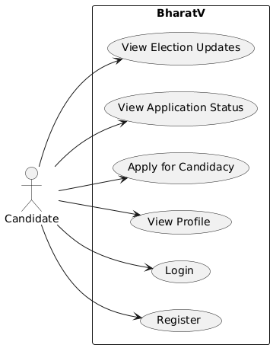
Figure 1: Use Case Diagram of Candidate

2. Voter Use Case
Actor: Voter
Use Cases:
- Register – A voter creates an account.
- Login – A voter logs into the system.
- View Profile – The voter can view and update their profile.
- View Election Updates – The voter receives updates about ongoing elections.
- View Election Results – The voter can check the results after elections.
- View Candidates – The voter can see the list of candidates contesting in the election.
- Cast Vote – The voter participates in the election by casting their vote.

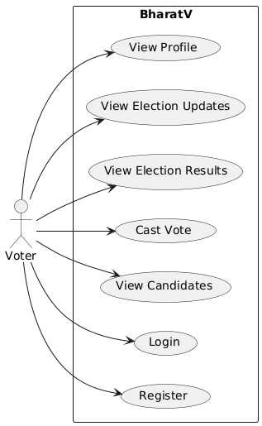
Figure 2: Use Case Diagram of Voter

3. Admin Use Case
Actor: Admin
Use Cases:
- Login – Admin logs into the system.
- Approve Voter Registrations – Admin verifies and approves voter registrations.
- Approve Candidate Registrations – Admin verifies and approves candidates.
- Manage Elections – Admin schedules elections and manages processes.
- View Election Results – Admin checks the election results.
- Declare Election Results – Admin officially declares the winners.

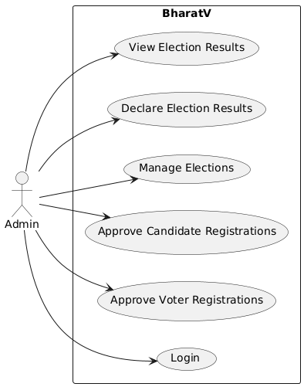
Figure 3: Use Case Diagram of Admin

4. Party Use Case
Actor: Political Party
Use Cases:
- Register – A party creates an account.
- Login – A party logs into the system.
- View Candidate Applications – The party reviews applications from candidates.
- Approve/Reject Candidates – The party decides whether to approve or reject a candidate.
- Forward Approved Candidates – The party forwards approved candidates to the election commission.
- Manage Party Candidates – The party handles its candidates contesting in different elections.

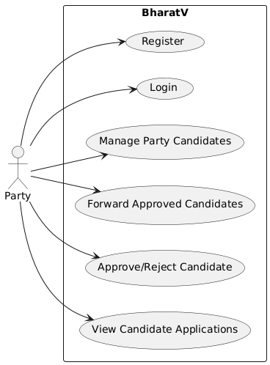
Figure 4: Use Case Diagram of Party

5. Returning Officer Use Case
Actor: Returning Officer
Use Cases:
- Register – The returning officer creates an account.
- Login – The returning officer logs into the system.
- View Applications – The returning officer checks candidate applications.
- Approve Candidates – The returning officer gives final approval to candidates.
- Finalize Candidate List – The returning officer prepares the final list of contestants.
- Monitor Election Process – The returning officer ensures that the election is conducted smoothly.

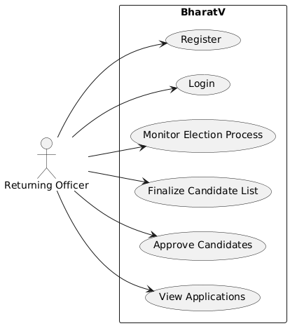
Figure 5: Use Case Diagram of Returning Officer

SEQUENCE DIAGRAM
The sequence diagram for BharatV Voting Platform illustrates the four key processes: User Registration, Candidate Application, Voting Process, and Result View, detailing interactions between the User, Frontend, Admin, System, Parties, Returning Officer, and Database. In User Registration, a user submits their details, which are validated and stored in the database, followed by admin approval before registration is confirmed. The Candidate Application process involves user authentication, application submission, storage, and review by a Party (if applicable) before final approval by the Returning Officer. Independent candidates bypass party approval and go directly to the Returning Officer. The Voting Process ensures secure authentication, voter eligibility verification, and vote recording in the database, providing confirmation to the user. Finally, the Result View allows users to request election results, which are retrieved from the database and displayed accordingly. The diagram has been improved by using dotted lines for response messages, incorporating the Returning Officer for approvals, and refining the party approval flow. These modifications ensure a structured, transparent, and secure election process within BharatV.

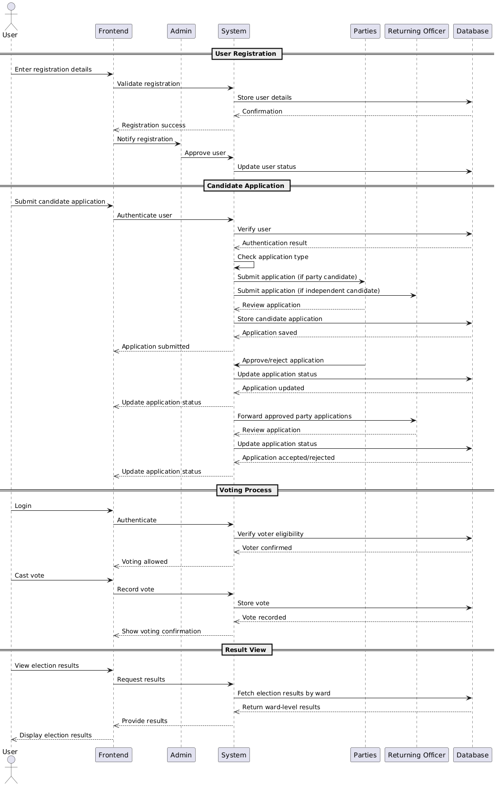
Figure 6: Sequence Diagram

4.2.2 State Chart Diagram
A State Chart Diagram is a powerful UML tool that visually represents the different states an object can be in and the transitions between them based on specific events. It is essential for understanding dynamic system behavior, ensuring clarity in workflows. Each state is depicted as a rounded rectangle, with transitions represented by labeled arrows, beginning with an initial state (a filled black circle) and concluding with a final state (a bordered black circle). For example, in the BharatV Voting System, the state diagram illustrates a voter's journey, starting from browsing the platform to registration, credential verification, authentication, and voting. Once authenticated, the voter can proceed to select a candidate, confirm their vote, and submit it, transitioning the system to a vote recorded state. From there, they may exit the system or view election results. If the voter logs out or experiences a session timeout, the system returns to the browsing state. These diagrams are crucial for system design, workflow analysis, and debugging, ensuring that all possible transitions are accounted for, leading to a more efficient, scalable, and well-documented system.

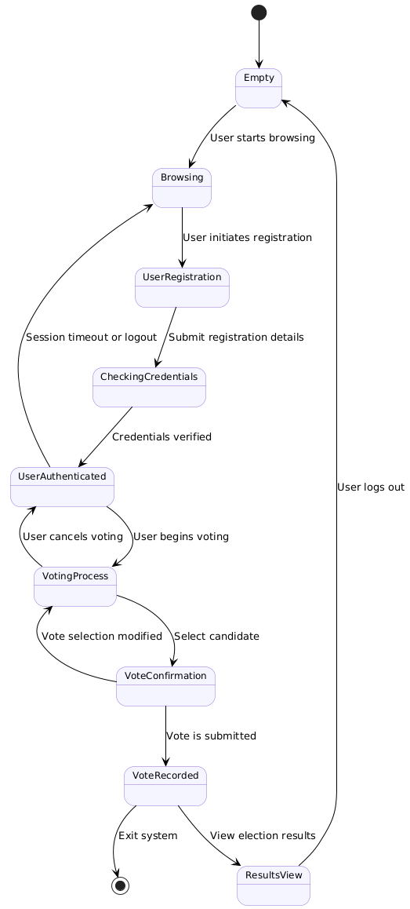
Figure 7: State Chart Diagram

Activity Diagram
An Activity Diagram is a powerful UML tool used to visually represent workflows, processes, or system activities by focusing on the sequence of actions and decision points. It helps model the dynamic behaviour of a system by showing how different activities transition from one to another. The diagram begins with an initial node, represented as a filled black circle, indicating the starting point of the process. Various activities, depicted as rounded rectangles, represent the tasks performed, while arrows define the flow of execution. Decision nodes, shown as diamonds, introduce conditional branching, allowing different paths based on logical conditions such as "Yes" or "No" outcomes. Additionally, fork and join nodes enable parallel processing, ensuring that multiple activities can execute simultaneously before synchronizing at a later stage. The diagram concludes with a final node, a black circle with a border, symbolizing the completion of the process. Activity diagrams are essential for visualizing complex workflows, analyzing decision-making steps, optimizing business processes, and designing system behaviors in software development. For instance, in the BharatV Voting System, an activity diagram could illustrate how a voter moves through different stages, such as logging into the system, verifying voter eligibility, selecting a candidate, casting and confirming a vote, and viewing election results. If the voter's login credentials are incorrect or the voter is found ineligible, the process terminates, demonstrating a clear transition to an end state. By using activity diagrams, developers, analysts, and stakeholders can effectively understand system operations, identify potential bottlenecks, and enhance workflow efficiency, making them a critical component of process modeling and software design.

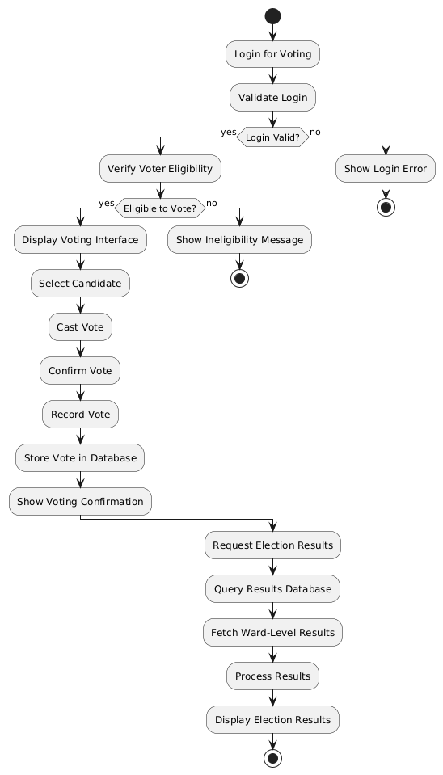
Figure 8: Activity Diagram of Voter

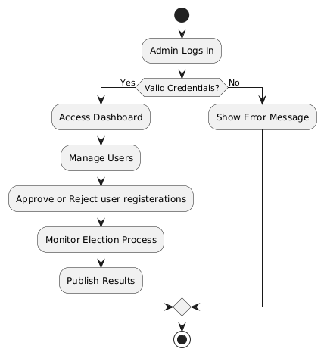
Figure 9: Activity Diagram of Admin

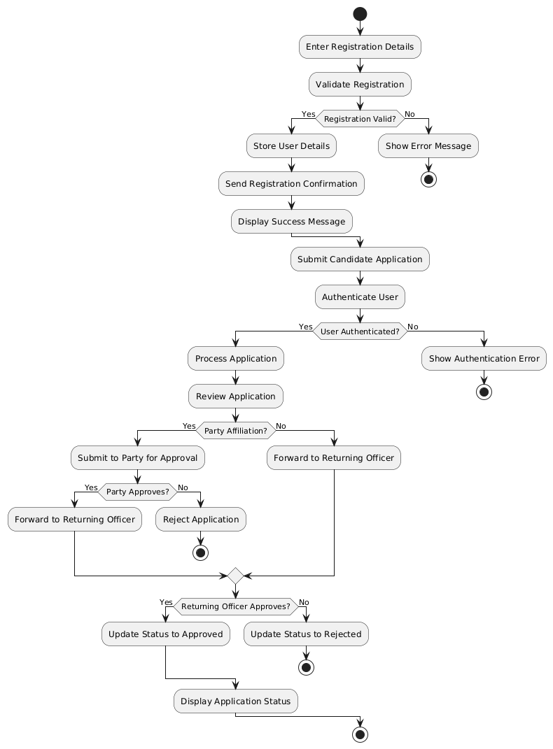

Figure 10: Activity Diagram of Candidate

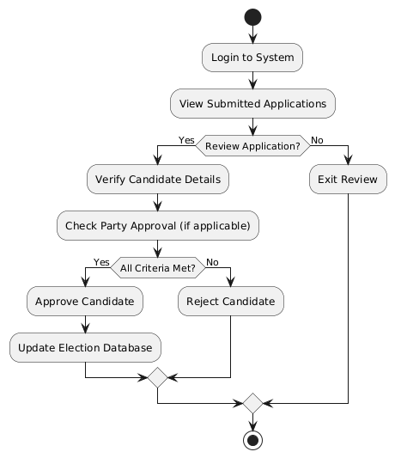
Figure 11: Activity Diagram of Returning Officer

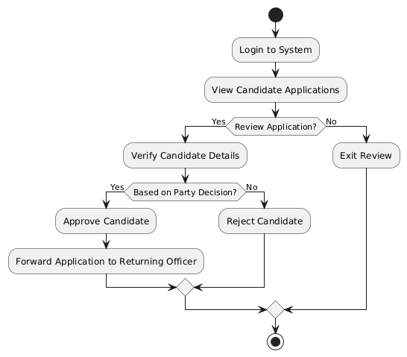

Figure 11: Activity Diagram of Party

Class Diagram

A Class Diagram is a fundamental component of Unified Modeling Language (UML) that visually represents the structure of a system by defining its classes, attributes, methods, and relationships among objects. It serves as a blueprint for software development, helping developers and system architects design, understand, and maintain complex systems. Each class is depicted as a rectangle divided into three sections: the class name, attributes, and methods (operations). Relationships between classes are illustrated using different association lines, including association, aggregation, composition, and inheritance (generalization), along with multiplicity indicators like one-to-one, one-to-many, or many-to-many. For example, in the BharatV Voting System, the class diagram includes key entities such as Users, Candidates, Returning Officers, Elections, Votes, and Results. The Users class may contain attributes like user_id, name, and role, with methods such as register() and login(). A Candidate class inherits from Users, adding specific attributes like party_id and ward_id, while a Returning Officer class includes functionalities like approveCandidate() and rejectCandidate(). The Votes class is linked to both Users (voters) and ContestingCandidates, ensuring a structured representation of the voting process. By providing a clear and structured view of system interactions, class diagrams enhance design clarity, scalability, maintainability, and code reusability, making them an essential tool in software engineering.

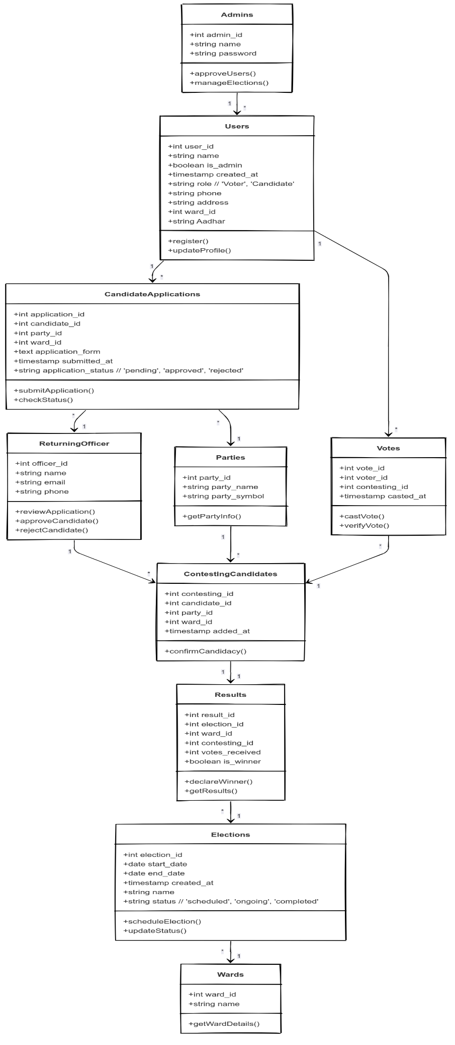
Figure 12: Class Diagram

Object Diagram
An Object Diagram is a crucial component of Unified Modeling Language (UML) that represents a snapshot of a system's objects and their relationships at a specific moment in time. It is derived from a Class Diagram but focuses on showing actual instances (objects) of classes rather than their structure. Each object is depicted as a rectangle with its name and attribute values, and the associations between them illustrate how they interact at runtime. Object diagrams are particularly useful for visualizing real-world scenarios, debugging, and validating class structures by demonstrating how data flows through the system. For example, in the BharatV Voting System, this object diagram showcases instances of key entities involved in an election process. A voter (user1) named John Doe, with a unique user_id (1) and assigned to Ward A, casts a vote (vote1) for a contesting candidate (contestingCandidate1). This candidate, represented by user2 (Jane Smith), belongs to a political party (party1: Democratic Party) and has submitted a candidate application (candidateApplication1) for Ward B. The election, depicted as election1 (Panchayat Election 2024), maintains details like start date, end date, and status. Once votes are cast, the result (result1) object records votes received and the winner status. Unlike class diagrams, which define the blueprint of a system, object diagrams provide a concrete representation of how objects interact in a given scenario. By using object diagrams, developers and system designers can validate system behavior, analyze dependencies, and refine the design to ensure smooth system operation.

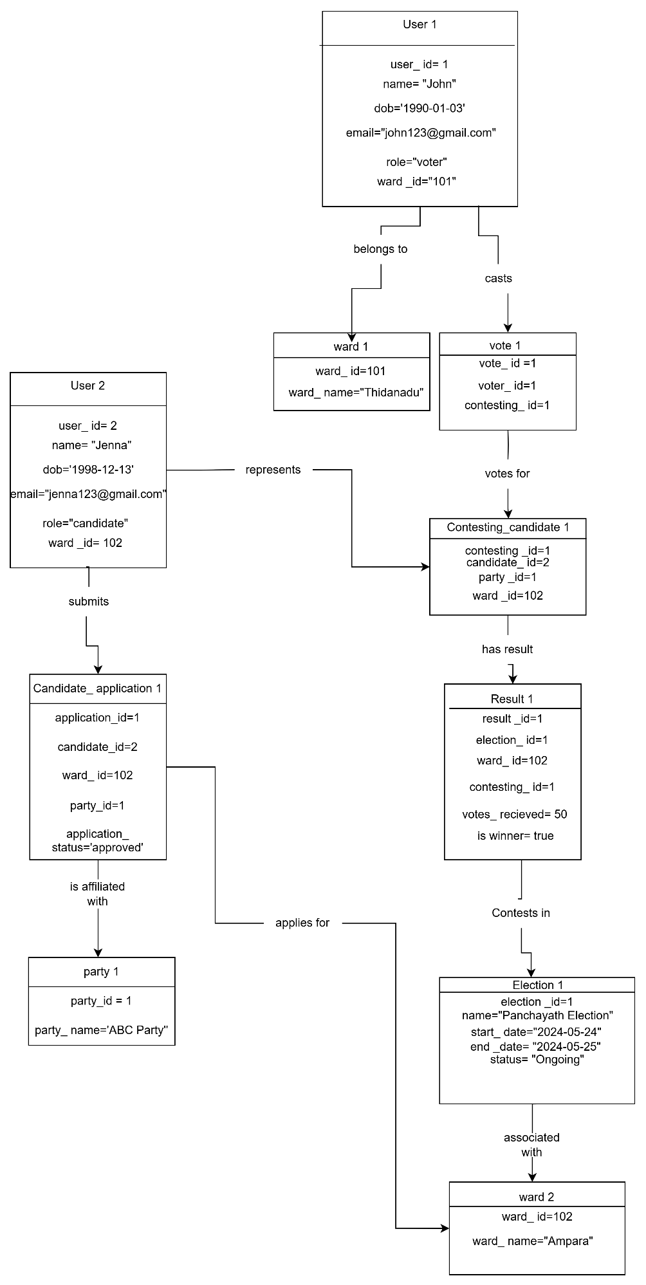
Figure 13: Object Diagram

Component Diagram
A Component Diagram in UML represents the high-level architecture of a system by depicting its software components, their dependencies, and interactions. It organizes the system into logical modules, showing how different parts communicate to perform specific functions. In the BharatV Voting System, key components include User Management, Candidate Registration, Voting Mechanism, Election Results Processing, and Database Services, where the User Interface (UI) component interacts with authentication services to verify users before accessing the voting system. dependencies between components ensure secure vote recording, result processing, and system scalability. This diagram helps developers understand module interactions, integration points, and maintainability, ensuring an efficient and robust system architecture.

4.2.8 Deployment Diagram
A Deployment Diagram in UML (Unified Modelling Language) is a structural diagram that visualizes the physical architecture of a system by depicting how software components are deployed across hardware nodes. It helps in understanding system infrastructure, hardware configurations, and the interactions between components. A deployment diagram consists of nodes (physical devices or execution environments) represented as cubes, and artifacts (software components like databases, applications, or services) shown inside nodes. Connections between nodes illustrate communication channels such as networks, protocols, or data exchanges. These diagrams are crucial for system architects and DevOps teams as they define the real-world execution environment of a software system.
For instance, in the BharatV Voting System, a deployment diagram could illustrate how the system operates across different physical servers. It may include an Application Server, hosting the PHP backend and handling user requests, a Database Server running MySQL to

store voter and election data, and a Client Device representing a user's browser or mobile app interacting with the system. The communication between these components occurs over a secure network (HTTPS), ensuring safe data exchange. If the system integrates third-party services for email verification or cloud storage, they are also depicted as external nodes.

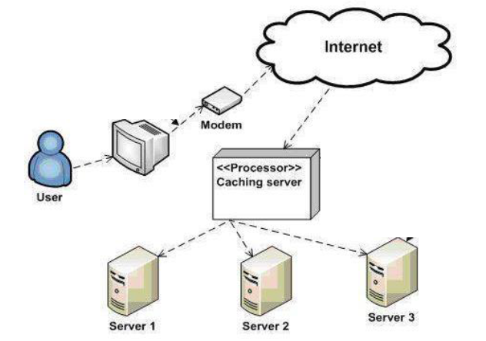

Figure 15: Deployment Diagram

4.3 USER INTERFACE DESIGN USING FIGMA

Form Name: Registration Form (Candidate and Voter Registration Form)

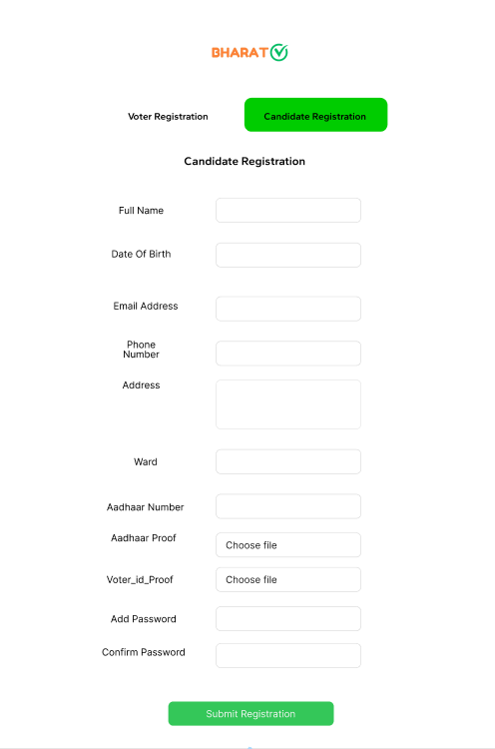

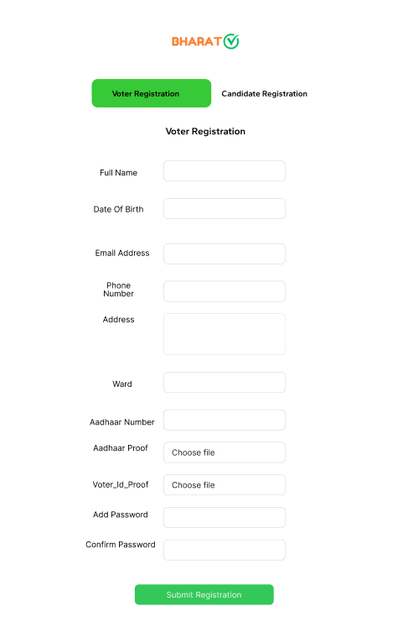

Form Name: Login Form

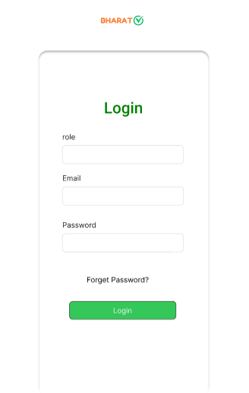

Form Name: Candidate Application Form

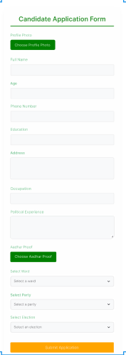

DATABASE DESIGN

4.4.1 Relational Database Management System (RDBMS)
A Relational Database Management System (RDBMS) is a type of database management system that stores data in tables with rows and columns, ensuring data integrity and relationships between entities. BharatV utilizes MySQL, an RDBMS, to manage election-related data efficiently.

How BharatV Uses RDBMS:
- Tables: The system consists of multiple relational tables such as users, candidate_applications, elections, parties, votes, and results.
- Relationships:
  - users table stores voter and candidate details.
  - candidate _ applications links candidates to their elections and parties.
  - elections manage details of each election.
  - votes store voting records linked to elections and contesting_candidates.
  - results track election outcomes.
By using MySQL, BharatV ensures data consistency, scalability, and efficient querying for election operations.

4.4.2 Normalization
Database Normalization is a process in relational database design that organizes data to minimize redundancy and improve integrity. It involves structuring tables so that data is stored efficiently, eliminating duplicate information while maintaining relationships between data elements. The primary objective of normalization is to reduce anomalies that can occur when inserting, updating, or deleting records. The process is carried out through multiple stages called normal forms, each introducing more strict rules for data organization.

First Normal Form
A table is in First Normal Form (1NF) if:
- All values in each column are atomic (indivisible).
- Each column contains only a single type of data.
- Each row is uniquely identifiable, meaning there is a primary key.

Example (Before 1NF - Unnormalized Table):
Student_ID | Student_Name | Courses | Contact
101 | Alice | Math, Science | 9876543210
102 | Bob | English | 8765432109
103 | Charlie | Science, History | 7654321098

Conversion to 1NF:
Student_ID | Student_Name | Course | Contact
101 | Alice | Math | 9876543210
101 | Alice | Science | 9876543210
102 | Bob | English | 8765432109
103 | Charlie | Science | 7654321098
103 | Charlie | History | 7654321098

Second Normal Form (2NF)
A table is in Second Normal Form (2NF) if:
- It is already in 1NF.
- It removes partial dependencies, meaning all non-key attributes must be fully dependent on the entire primary key.
- If the table has a composite primary key, non-key attributes should not be dependent on just a part of the primary key.
Example (Before 2NF - 1NF Table):
Student_ID | Student_Name | Course | Contact
101 | Alice | Math | 9876543210
101 | Alice | Science | 9876543210
102 | Bob | English | 8765432109
103 | Charlie | Science | 7654321098
103 | Charlie | History | 7654321098

Conversion to 2NF:
Students Table
Student_ID | Student_Name | Contact
101 | Alice | 9876543210
102 | Bob | 8765432109
103 | Charlie | 7654321098

Enrollment Table
Student_ID | Course
101 | Math
101 | Science
102 | English
103 | Science
103 | History

Third Normal Form (3NF)
A table is in Third Normal Form (3NF) if:
- It is already in 2NF.
- It removes transitive dependencies, meaning non-key attributes should not depend on other non-key attributes.
- All attributes must be directly dependent on the primary key.

Example (Before 3NF - 2NF Tables):
Students Table (Before 3NF)
Student_ID | Student_Name | Contact | Address
101 | Alice | 9876543210 | New York
102 | Bob | 8765432109 | Los Angeles
103 | Charlie | 7654321098 | Chicago

Enrollment Table
Student_ID | Course
101 | Math
101 | Science
102 | English
103 | Science
103 | History

Conversion to 3NF:
Students Table
Student_ID | Student_Name
101 | Alice
102 | Bob
103 | Charlie

Contact Table
Contact_ID | Student_ID | Phone | Address
1 | 101 | 9876543210 | New York
2 | 102 | 8765432109 | Los Angeles
3 | 103 | 7654321098 | Chicago

Enrollment Table
Student_ID | Course
101 | Math
101 | Science
102 | English
103 | Science
103 | History

4.4.3 Sanitization
Sanitization is the process of cleaning and filtering user inputs to prevent malicious data from being processed or stored in a web application. It is a crucial security measure that helps protect databases, prevent cross-site scripting (XSS), and mitigate SQL injection attacks. When users submit data through forms, URL parameters, or API requests, there is always a risk of injecting harmful scripts or unauthorized SQL queries that can compromise the system. Sanitization ensures that only safe, well-formed, and expected data is accepted and stored.
4.4.4 Indexing
Indexing is a way to optimize the performance of a database by minimizing the number of disk accesses required when a query is processed. It is a data structure technique which is used to quickly locate and access the data in a database. Indexes are created using one or more database columns. Indexing is also done to optimize various query responses.

4.5 TABLE DESIGN
1. Table name: users
Primary key: id
Foreign key: ward_id references table tbl_wards
Sl.No | Field Name | Data Type (Size) | Key Constraints | Description Of the Field
1 | id | INT | PRIMARY KEY, AUTO_INCREMENT | Unique identifier
2 | name | VARCHAR (100) | NOT NULL | name of the user.
3 | dob | DATE | NOT NULL | Date of birth
4 | Email | VARCHAR (100) | UNIQUE, NOT NULL | Email address
5 | Email _verified | BOOLEAN | DEFAULT FALSE | Indicates if the email of the user is verified or not
6 | password | VARCHAR (255) | NOT NULL | Encrypted password
7 | Role | ENUM ('voter', 'candidate') | NOT NULL | Role of the user
8 | Phone | VARCHAR (15) | NOT NULL | Contact number
9 | address | TEXT | NOT NULL | Residential address
10 | Ward _id | INT | FOREIGN KEY REFERENCES users(id) | Associated ward of the user.
11 | Approved _ by _ admin | BOOLEAN | DEFAULT FALSE | Indicates if admin has approved the user.
12 | Updated_ at | TIMESTAMP | DEFAULT CURRENT_ TIMESTAMP | Timestamp when the user was approved
13 | Aadhaar number | VARCHAR (12) | NOT NULL UNIQUE | Aadhaar Number of user
14 | Aadhaar_ file | VARCHAR (255) | NOT NULL | Aadhaar file of the user
15 | Voter_ id_ proof | VARCHAR (255) | NOT NULL | Voter_id file of the user
16 | created_ at | TIMESTAMP | DEFAULT CURRENT_TIMESTAMP | Timestamp when the user was registered.
17 | Profile _ photo | VARCHAR (255) | NOT NULL | Profile Photo of the user

2.Table name: wards
Primary key: ward _ id
Foreign key: NIL
Sl. No | Field Name | Data Type  (Size) | Key Constraints | Description Of the Field
1 | ward_id | INT | PRIMARY KEY  AUTO INCREMENT | Unique identifier for the table
2 | ward_name | VARCHAR (100) | NOT NULL | Name of the ward.

3.Table name: parties
Primary key: party_ id
Foreign key: NIL
Sl. No | Field Name | Data Type  (Size) | Key Constraints | Description Of the Field
1 | party_id | INT | PRIMARY KEY  AUTO INCREMENT | Unique identifier for the table
2 | party _name | VARCHAR (100) | UNIQUE, NOT NULL | Name of the ward.
3 | party_symbol | VARCHAR (255) | NOT NULL | Symbol/logo representing the party.
4 | password | VARCHAR (255) | NOT NULL | Password for party login
5 | email | VARCHAR (255) | NOT NULL UNIQUE | Email for party login

4. Table name: candidate_ applications
Primary key: application_ id
Foreign key: id references table tbl_users, party_id references table tbl_parties, ward_id references table tbl_wards, election_id references table tbl_elections

Sl. No | Field Name | Data Type  (Size) | Key Constraints | Description Of the Field
1 | application_id | INT (11) | PRIMARY KEY, AUTO_INCREMENT | Unique identifier for the table
2 | id | INT (11) | FOREIGN KEY REFERENCES users(id) | ID of the candidate applying.
3 | party_id | INT (11) | FOREIGN KEY REFERENCES parties(party_id) | Party under which the candidate applies.
4 | application_form | TEXT | NOT NULL | Application form of the candidate
5 | ward_id | INT (11) | FOREIGN KEY REFERENCES wards(ward_id) | Ward for which the candidate is applying.
6 | election _ id | INT (11) | FOREIGN KEY  REFERENCES  Elections (election_id) | Election for which the candidate has applied
7 | application_party_approval | ENUM ('pending', 'approved', 'rejected') | DEFAULT 'pending' | Party approval status of the application.
8 | application_ro_  approval | ENUM ('pending', 'approved', 'rejected') | DEFAULT ‘pending’ | Returning officer approval status of application
9 | created_at | TIMESTAMP | DEFAULT CURRENT_TIMESTAMP | Timestamp of application submission.
10 | independent_  party_name | VARCHAR (100) | DEFAULT NULL | Party name of the independent candidate
11 | independent_  party_symbol | VARCHAR (100) | DEFAULT NULL | Party symbol of the independent candidate
12 | application_type | ENUM (‘party’  ,’independent’) | DEFAULT ‘party’ | Application type

5. Table name: contesting _candidates
Primary key: contesting_ id
Foreign key: id references table tbl_users, party_id references table tbl_parties, ward_id references table tbl_wards, election_id references table tbl_elections
Sl. No | Field Name | Data Type  (Size) | Key Constraints | Description Of the Field
1 | contesting_id | INT (11) | PRIMARY KEY, AUTO_INCREMENT | Unique identifier for the table
2 | id | INT (11) | FOREIGN KEY REFERENCES users(id) | ID of the candidate applying.
3 | party_id | INT (11) | FOREIGN KEY REFERENCES parties(party_id) | Party under which the candidate applies.
4 | ward_id | INT (11) | FOREIGN KEY REFERENCES wards(ward_id) | Ward for which the candidate is applying.
5 | election _ id | INT (11) | FOREIGN KEY  REFERENCES  Elections (election_id) | Election for which the candidate has applied
6 | added_at | TIMESTAMP | DEFAULT CURRENT_TIMESTAMP | Timestamp of adding the contesting candidates.
7 | independent_  party_name | VARCHAR (100) | DEFAULT NULL | Party name of the independent candidate
8 | independent_  party_symbol | VARCHAR (100) | DEFAULT NULL | Party symbol of the independent candidate
9 | application_type | ENUM (‘party’  ,’independent’) | DEFAULT ‘party’ | Application type

6. Table name: elections
Primary key: election_ id
Foreign key: NIL
Sl. No | Field Name | Data Type  (Size) | Key Constraints | Description Of the Field
1 | election_id | INT (11) | PRIMARY KEY, AUTO_INCREMENT | Unique identifier for the table
2 | election_title | VARCHAR (100) | NOT NULL | Name of the election.
3 | description | TEXT | DEFAULT NULL | Description about the election
4 | ward_ids | TEXT | NOT NULL | Ward ids for elections stored as a string
5 | start_date | DATE | NOT NULL | Election start date
6 | end_date | DATE | NOT NULL | Election end date
7 | status | ENUM ('scheduled', 'ongoing', 'completed') | NOT NULL,  DEFAULT 'scheduled' | Status of the election
8 | created_at | TIMESTAMP | DEFAULT CURRENT_TIMESTAMP | When was the election created
9 | result_status | ENUM (‘pending’,  ’published’) | DEFAULT  ‘pending’ | Status whether the result of election is  Published or not
10 | results_ published_ date | DATETIME | DEFAULT NULL | When the result was published
7. Table name: votes
Primary key: vote_ id
Foreign key: id references table tbl_users, contesting_id references table tbl_contesting_ candidates table, ward_id references table tbl_wards, election_id references tbl_elections
Sl. No | Field Name | Data Type  (Size) | Key Constraints | Description Of the Field
1 | vote_id | INT (11) | PRIMARY KEY, AUTO_INCREMENT | Unique identifier of the table
2 | id | INT (11) | FOREIGN KEY REFERENCES users(id) | ID of the user
3 | contesting_id | INT (11) | FOREIGN KEY REFERENCES contesting_candiates(id) | Contesting id of the candidate
4 | ward_id | INT (11) | FOREIGN KEY REFERENCES wards(ward_id) | Specify the ward
5 | election _ id | INT (11) | FOREIGN KEY  REFERENCES  Elections (election_id) | Election for which the vote has been casted
6 | casted_at | TIMESTAMP | DEFAULT CURRENT_TIMESTAMP | Timestamp when the vote was cast.

8. Table name: results
Primary key: result_ id
Foreign key: contesting_id references table tbl_contesting_ candidates table, ward_id references table tbl_wards, election_id references tbl_elections
Sl. No | Field Name | Data Type  (Size) | Key Constraints | Description Of the Field
1 | result_id | INT (11) | PRIMARY KEY, AUTO_INCREMENT | Unique identifier of the table
2 | election _ id | INT (11) | FOREIGN KEY  REFERENCES  Elections (election_id) | Election result
3 | contesting_id | INT (11) | FOREIGN KEY REFERENCES contesting_candiates(id) | Contesting id of the candidate
4 | ward_id | INT (11) | FOREIGN KEY REFERENCES wards(ward_id) | Specify the ward
5 | votes_received | INT | NOT NULL | Total votes received by the candidate.
6 | is_winner | BOOLEAN | DEFAULT FALSE | Indicates if the candidate is the winner.

CHAPTER 5

SYSTEM TESTING
  - INTRODUCTION
System Testing is a crucial phase in the Software Development Life Cycle (SDLC) where a complete and fully integrated system is tested to ensure it meets the specified requirements. It is a black box testing technique that evaluates the system's overall functionality, performance, security, and reliability. Unlike unit and integration testing, which focus on individual components, system testing verifies the interactions between different modules and external interfaces. This ensures that the software works as expected in a real-world environment.
The primary objective of system testing is to detect defects and validate that the system behaves correctly under various conditions, including normal, boundary, and stress scenarios. It involves different types of testing, such as functional testing, performance testing, security testing, usability testing, and compatibility testing. For example, in a voting platform like BharatV, system testing would involve checking whether users can successfully register, log in, vote, and retrieve election results while ensuring that security measures like data encryption and access control are properly implemented.
System testing is typically performed by a dedicated testing team after integration testing and before user acceptance testing (UAT). It is executed in an environment that closely resembles the production setup to identify potential issues before deployment. A well-structured system testing process helps improve software quality, reliability, and user experience, ensuring that the final product meets the business and technical requirements before being released to the end users.

TEST PLAN

A test plan is a detailed document that outlines the overall strategy, objectives, scope, resources, and schedule for testing a software project. It serves as a roadmap for the testing process, ensuring systematic validation of functionalities to identify defects before deployment. The test plan defines various testing levels, including unit testing, integration testing, system testing, regression testing, and user acceptance testing, specifying the approach for each. It includes key components such as test objectives, test scope (what will and won’t be tested), test deliverables, required testing environments, entry and exit criteria, and risk assessment. Additionally, it identifies roles and responsibilities, ensuring efficient coordination among testers, developers, and other stakeholders. The document also outlines the test execution schedule, tools and frameworks to be used, reporting mechanisms, and defect tracking processes. By following a well-structured test plan, teams can enhance software quality, ensure compliance with requirements, minimize production failures, and improve overall project reliability.

Unit Testing
Unit testing is a software testing method that focuses on verifying the functionality of individual components, functions, or modules in isolation to ensure they work correctly. It is typically performed by developers during the coding phase using automated testing frameworks like PHPUnit for PHP, JUnit for Java, or PyTest for Python. By executing test cases with predefined inputs and expected outputs, unit testing helps identify and fix bugs early, improving code quality and maintainability. It also promotes modular development, making the software easier to update and extend while serving as documentation for future developers.

Integration Testing
Integration testing is a systematic approach that focuses on building the program’s structure while simultaneously testing it to detect interface defects. It involves integrating unit-tested components according to the design and ensuring they function cohesively. Unlike unit testing, which examines individual components in isolation, integration testing evaluates how different modules interact, forming a complete system. However, debugging can be complex since pinpointing errors becomes challenging as the program size grows. Fixing one issue may introduce new ones, creating a repetitive cycle of testing and correction. After unit testing is completed, all modules are combined and tested to identify any inconsistencies in their interaction. Through this process, discrepancies in the program’s structure are resolved, leading to a more refined and stable system.

Validation Testing or System Testing

System testing is the final phase of the testing process, where the entire software system, including all forms, code, modules, and class structures, is thoroughly evaluated. This stage ensures that every aspect of the application functions correctly as a whole. It is commonly referred to as system testing or black box testing, where the primary focus is on validating the software’s functional requirements without examining the internal code structure. Using this approach, testers create input conditions to verify that the system meets all predefined requirements. Black box testing helps identify a wide range of issues, including missing or incorrect functionalities, interface defects, errors in data structures or external data access, performance bottlenecks, and problems related to initialization and termination. By systematically uncovering these defects, system testing ensures that the software is ready for deployment and meets user expectations.

Output Testing or User Acceptance Testing

User acceptance testing (UAT) is conducted to ensure that the software meets the organization's requirements and aligns with business needs. Throughout the development process, the software should remain adaptable to user feedback, allowing for modifications when necessary. This phase focuses on evaluating critical aspects such as input screen designs and output screen designs to ensure they function as expected. Testing is performed using carefully prepared test data, which plays a crucial role in validating the system's performance and accuracy. Once the test data is applied, the system is examined for potential errors, and any identified issues are corrected. This iterative process continues until the software meets all specified requirements, ensuring that it is fully functional and ready for deployment.
    - Automation Testing
Automation testing is a process where software and other computer products are tested automatically to ensure they meet strict standards and function as expected. It is designed to verify that the hardware or software performs precisely as intended by identifying errors, defects, and potential issues that may arise during development. Unlike manual testing, automation testing uses scripted sequences to examine the software’s functionality, allowing tests to be executed at any time of the day. After running the tests, the results are recorded and analyzed, providing insights into detected issues. These findings can also be compared with previous test results to track improvements and ensure consistency in software performance.
    - Selenium Testing
Selenium is an open-source tool designed to automate web browsers, enabling efficient web application testing. It provides a unified interface that allows testers to write test scripts in multiple programming languages, including Java, Ruby, NodeJS, PHP, Perl, Python, and C#. Selenium is widely used for automating cross-browser compatibility testing, ensuring that web applications function correctly across different browsers. It supports testing for various types of web applications, whether they are responsive, progressive, or standard, to maintain high-quality performance. As a free and open-source software, Selenium is a popular choice among developers and testers for automating web-based testing efficiently.

Example:
Test Case 1

Code
import pytest
import time
import json
from selenium import webdriver
from selenium.webdriver.common.by import By
from selenium.webdriver.common.action_chains import ActionChains
from selenium.webdriver.support import expected_conditions
from selenium.webdriver.support.wait import WebDriverWait
from selenium.webdriver.common.keys import Keys
from selenium.webdriver.common.desired_capabilities import DesiredCapabilities

class TestLogin():
def setup_method(self, method):
self.driver = webdriver.Chrome()
self.vars = {}

def teardown_method(self, method):
self.driver.quit()

def test_login(self):
self.driver.get("http://localhost/Bharatv-main/home.php")
self.driver.set_window_size(831, 798)
self.driver.find_element(By.CSS_SELECTOR, ".slide:nth-child(3) .cta-primary").click()
self.driver.find_element(By.ID, "role").click()
dropdown = self.driver.find_element(By.ID, "role")
dropdown.find_element(By.XPATH, "//option[. = 'Candidate']").click()
self.driver.find_element(By.ID, "email").click()
self.driver.find_element(By.ID, "email").send_keys("rohithrnair2027@mca.ajce.in")
self.driver.find_element(By.ID, "password").click()
self.driver.find_element(By.ID, "password").send_keys("Rohith@2003")
self.driver.find_element(By.CSS_SELECTOR, "button").click()
self.driver.find_element(By.CSS_SELECTOR, ".sidebar-logout > button").click()

Eg.Screenshot

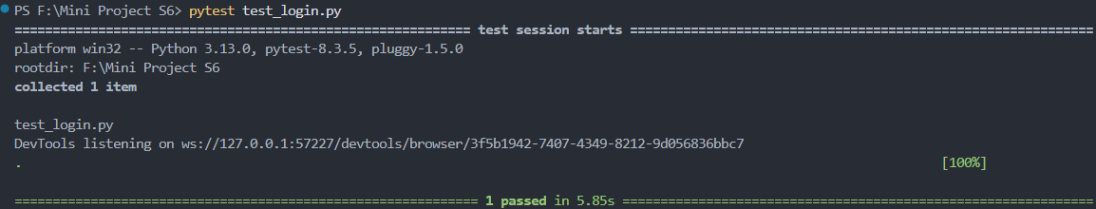

Test Report
Test Case 1
Project Name: BharatV- Panchayath Election Voting System
Login Test Case
Test Case ID: Test_1 |  |  | Test Designed By: Abey Mathew
Test Priority(Low/Medium/High): High |  |  | Test Designed Date: 04/04/2025
Module Name: Login |  |  | Test Executed By : Mr. T.J Jobin
Test Title : Verify Login  with valid username and password |  |  | Test Execution Date: 04/04/2025
Description: Login Page Test
Pre-Condition :User has valid username and password
Step | Test Step | Test Data | Expected Result | Actual Result | Status(Pass/  Fai l)
1 | Navigate to the login page |  | Display Login page | Login page displayed | pass
2 | Valid username Entered | Username : | Candidate should enter the main page | Candidate entered to the main page | pass
3 | Valid password entered | Password:
4 | Click on  Login Button
Post-Condition: Username and password is checked with database values for successful login

Test Case 2:

Code
import pytest
import time
from selenium import webdriver
from selenium.webdriver.common.by import By
from selenium.webdriver.common.keys import Keys
from selenium.webdriver.support.ui import WebDriverWait
from selenium.webdriver.support import expected_conditions as EC

class TestProfile:
def setup_method(self, method):
self.driver = webdriver.Chrome()
self.driver.maximize_window()
self.wait = WebDriverWait(self.driver, 10)

def teardown_method(self, method):
self.driver.quit()

def test_profile(self):
self.driver.get("http://localhost/Bharatv-main/login.php")
role_dropdown = self.driver.find_element(By.ID, "role")
role_dropdown.click()
role_dropdown.find_element(By.XPATH, "//option[. = 'Voter']").click()

self.driver.find_element(By.ID, "email").send_keys("johnjosephjohn748@gmail.com")
password_input = self.driver.find_element(By.ID, "password")
password_input.send_keys("John@2003")
password_input.send_keys(Keys.ENTER)
profile_button = self.wait.until(
EC.element_to_be_clickable((By.CSS_SELECTOR, ".nav-menu > button:nth-child(1)"))
)
profile_button.click()

toggle_edit = self.wait.until(
EC.presence_of_element_located((By.ID, "toggleEdit"))
)
toggle_edit.click()
name_input = self.wait.until(
EC.presence_of_element_located((By.NAME, "name"))
)
name_input.clear()
name_input.send_keys("John Joseph John")

save_button = self.driver.find_element(By.ID, "saveChanges")
save_button.click()

Screenshot


Test report
Test Case 2
Project Name: BharatV- Panchayath Election Voting System
Profile Update Test Case
Test Case ID: Test_2 |  |  | Test Designed By: Abey Mathew
Test Priority(Low/Medium/High): High |  |  | Test Designed Date: 04/04/2025
Module Name: Profile Update |  |  | Test Executed By : Mr. T.J Jobin
Test Title : Update Profile of a user in his main page |  |  | Test Execution Date: 04/04/2025
Description: Update user profile Test

Pre-Condition :User has valid email and password
Step | Test Step | Test Data | Expected Result |  | Actual Result |  | Status(Pass/  Fai l)
1 | Launch browser and navigate to login page |  | Login page is displayed |  | Login page displayed |  | Pass
2 | Select role from dropdown | Role: Voter | Role selected successfully | Role selected successfully |  | Pass
3 | Enter valid email | Email: johnjosephjohn748@gmail.com | Email field accepts valid input |  | Valid email entered |  | Pass
4 | Enter valid password and login | Password: John@2003 | Redirected to dashboard/homepage |  | Redirected to user dashboard |  | Pass
5 | Click on profile button |  | Profile section is displayed |  | Profile section loaded successfully |  | Pass
6 | Click on edit profile button |  | Editable fields are displayed |  | Fields became editable |  | Pass
7 | Update name in the profile | Name: John Joseph John | Name is updated in input field |  | Name updated currently |  | Pass
8 | Click on Save Changes button |  | Changes are saved, confirmation shown or data updated in DB |  | Changes saved successfully |  | Pass
Post-Condition: The updated profile information is successfully saved in the database and is accurately reflected when the profile page.

Test Case 3:

Code
import pytest
import time
from selenium import webdriver
from selenium.webdriver.common.by import By
from selenium.webdriver.common.keys import Keys
from selenium.webdriver.support.ui import WebDriverWait
from selenium.webdriver.support import expected_conditions as EC

class TestPassword:
def setup_method(self, method):
self.driver = webdriver.Chrome()
self.driver.maximize_window()
self.wait = WebDriverWait(self.driver, 15)

def teardown_method(self, method):
self.driver.quit()

def test_password(self):
driver = self.driver
wait = self.wait

driver.get("http://localhost/Bharatv-main/login.php")

try:
wait.until(EC.element_to_be_clickable((By.ID, "role"))).click()
driver.find_element(By.XPATH, "//option[text()='Candidate']").click()
print("Selected role: Candidate")
except:
print(" Failed to select role")
driver.save_screenshot("error_role.png")
raise

try:
wait.until(EC.presence_of_element_located((By.ID, "email"))).send_keys("abeymathew2003@gmail.com")
driver.find_element(By.ID, "password").send_keys("Amt@2003", Keys.ENTER)
print(“ Submitted login form")
except:
print(“ Failed to fill login form")
driver.save_screenshot("error_login.png")
raise

try:
time.sleep(3)
driver.save_screenshot("after_login.png")
print(" Logged in successfully")
except:
print("Login may have failed")
raise

try:
change_pass_btn = wait.until(
EC.element_to_be_clickable((By.XPATH, "//button[contains(text(), 'Settings')]"))
)
change_pass_btn.click()
print(" Clicked Change Password button")
except:
print(" Failed to find or click 'Change Password' button")
driver.save_screenshot("missing_change_password.png")
raise

try:
wait.until(EC.presence_of_element_located((By.ID, "current_password"))).send_keys("Amt@2003")
driver.find_element(By.ID, "new_password").send_keys("Abey@2003")
driver.find_element(By.ID, "confirm_password").send_keys("Abey@2003")
driver.find_element(By.ID, "submit_password").click()
print(" Submitted password change")
except:
print(" Failed to complete password change form")
driver.save_screenshot("form_error.png")
raise

Screenshot

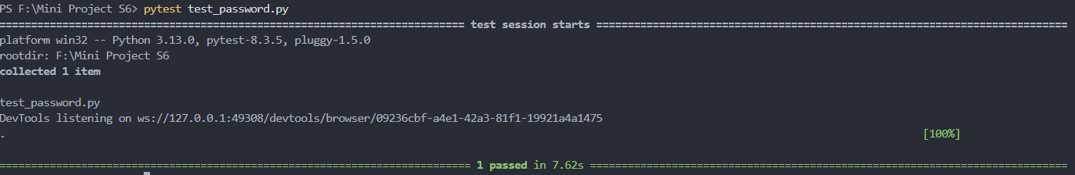

Test Report

Test Case 3
Project Name: BharatV- Panchayath Election Voting System
Password Change Test Case
Test Case ID: Test_3 |  |  | Test Designed By: Abey Mathew
Test Priority(Low/Medium/High): High |  |  | Test Designed Date: 04/04/2025
Module Name: User Account Settings |  |  | Test Executed By : Mr. T.J Jobin
Test Title : Verify password change functionality |  |  | Test Execution Date: 04/04/2025
Description: Verify that a user can successfully change their password
Pre-Condition :User has valid email and password
Step | Test Step | Test Data | Expected Result | Actual Result | Status(Pass/  Fai l)
1 | Launch browser and navigate to login page |  | Login page is displayed | Login page displayed | Pass
2 | Select role from dropdown | Role: Candidate | Role selected successfully | Role selected successfully | Pass
3 | Enter valid email | Email: johnjosephjohn748@gmail.com | Redirected to candidate dashboard | Logged in successfully | Pass
4 | Enter valid password and login | Password: John@2003
5 | Click on Settings/Change Password button |  | Password change form appears | Change Password form opened | Pass
6 | Fill out the form and submit | Current: Amt@2003  New: Abey@2003  Confirm: Abey@2003 | Password updated and success message shown | Password successfully changed | Pass
Post-Condition: Password is updated in the database and used for future logins

Test Case 3:

Code
import pytest
import time
from selenium import webdriver
from selenium.webdriver.common.by import By
from selenium.webdriver.support.ui import WebDriverWait
from selenium.webdriver.support import expected_conditions as EC

class TestVotingtest:
def setup_method(self, method):
self.driver = webdriver.Chrome()
self.wait = WebDriverWait(self.driver, 10)
self.vars = {}

def teardown_method(self, method):
self.driver.quit()

def test_votingtest(self):
driver = self.driver
wait = self.wait
driver.get("http://localhost/Bharatv-main/login.php")
driver.set_window_size(1060, 789)

role_dropdown = wait.until(EC.presence_of_element_located((By.ID, "role")))
role_dropdown.click()
role_dropdown.find_element(By.XPATH, "//option[. = 'Voter']").click()
driver.find_element(By.ID, "email").send_keys("abeymathew2027@mca.ajce.in")
driver.find_element(By.ID, "password").send_keys("James@2003")
driver.find_element(By.CSS_SELECTOR, "button").click()
wait.until(EC.element_to_be_clickable((By.CSS_SELECTOR, "button:nth-child(2)"))).click()
wait.until(EC.element_to_be_clickable((By.CSS_SELECTOR, ".vote-button"))).click()

try:
# Wait for the specific candidate radio input
candidate_radio = wait.until(EC.presence_of_element_located((By.ID, "candidate_9")))
candidate_radio.click()
except:
# Fallback if the specific ID is not found
driver.save_screenshot("candidate_not_found.png")
print("candidate_9 not found. Screenshot saved.")
assert False, "Candidate not found"
wait.until(EC.element_to_be_clickable((By.CSS_SELECTOR, ".fa-check-circle"))).click()
alert = wait.until(EC.alert_is_present())
assert alert.text == "Are you sure you want to submit your vote? This action cannot be undone."
alert.accept()
driver.execute_script("window.scrollTo(0, document.body.scrollHeight);")
wait.until(EC.element_to_be_clickable((By.CSS_SELECTOR, ".sidebar-logout > button")))

Screenshot

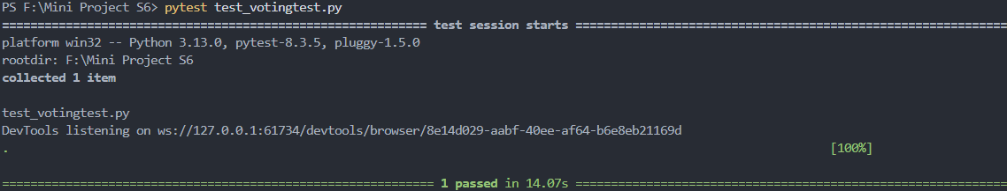

Test Report
Test Case 4
Project Name: BharatV- Panchayath Election Voting System
Voting Test Case
Test Case ID: Test_4 |  |  | Test Designed By: Abey Mathew
Test Priority(Low/Medium/High): High |  |  | Test Designed Date: 04/04/2025
Module Name: Voting Module |  |  | Test Executed By : Mr. T.J Jobin
Test Title : Verify vote submission functionality |  |  | Test Execution Date: 04/04/2025
Description: verify that a voter can log in, navigate to the election page, select a candidate, confirm the vote, and successfully log out.
Pre-Condition :User has valid email and password and election must be active.
Step | Test Step | Test Data | Expected Result | Actual Result | Status
1 | Open login page in browser |  | Login page is displayed | Login page displayed | Pass
2 | Select "Voter" from role dropdown | Role: Voter | Role selected | Role selected | Pass
3 | Enter login credentials and submit | Email: abeymathew2027@mca.ajce.in  Password: James@2003 | Redirected to voter dashboard | Dashboard loaded | Pass
4 | Navigate to vote page
5 | Select a candidate | Candidate ID: candidate_9 | Candidate selected | Candidate selected | Pass
6 | Click confirm vote icon |  | Confirmation popup appears | Popup displayed | Pass
7 | Confirm vote in alert | Alert Text: “Are you sure you want to submit your vote?” | Alert accepted and vote submitted | Alert handled and vote submitted | Pass
Post-Condition: The vote is recorded in the database and Voter cannot vote again.

CHAPTER 6

IMPLEMENTATION

INTRODUCTION

IMPLEMENTATION PROCEDURES

Explanation

User Training
Explanation

Training on the Application Software
Explanation

System Maintenance
Explanation

    - Hosting
Explanation

Eg.000Webhost
Explanation

Procedure for hosting a website on 000Webhost:
Step 1: explanation
Step 2: explanation
Step 3: explanation
.
.
Hosted Website:
Hosted Link: https://abc.000webhostapp.com
Hosted Link QR Code
Screenshot

CHAPTER 7

CONCLUSION AND FUTURE SCOPE

CONCLUSION

The BharatV voting platform successfully integrates a secure, transparent, and efficient online election management system that streamlines the entire electoral process, from voter registration to result declaration. By implementing a well-structured user hierarchy—including voters, candidates, parties, administrators, and returning officers. The system ensures seamless interactions while maintaining the integrity of elections. The incorporation of email verification for registration, profile management with photo uploads, and dynamic election listings based on wards enhances user experience and accessibility. The candidate application workflow, where party-affiliated candidates require party approval before being forwarded to the returning officer, ensures proper validation, while independent candidates directly submit their applications for approval. Robust database normalization techniques have been applied to ensure data consistency, while PHP, MySQL, and JavaScript provide a responsive, real-time experience for users. Security measures such as sanitization, authentication, and vote validation protect against fraud and unauthorized access. Furthermore, the system offers a voter history feature, allowing users to track their participation in elections, while real-time election results ensure transparency. The modern UI with a green and orange theme makes navigation intuitive, reinforcing a patriotic feel. Through effective use of UML diagrams—such as class diagrams, sequence diagrams, and object diagrams. The system's architecture has been clearly defined, ensuring scalability, maintainability, and future enhancements. In conclusion, BharatV is a robust, scalable, and user-friendly digital voting platform that leverages technology to uphold democracy, providing a secure, efficient, and transparent election process that can be expanded and improved for future implementations.

  - FUTURE SCOPE
- Blockchain-Based Voting – Implement blockchain technology to enhance security, transparency, and immutability in the voting process.
- AI-Based Voter Verification – Use AI for facial recognition and biometric authentication to prevent voter fraud.
- Mobile Application Development – Launch an Android and iOS app for seamless voting and real-time election updates.
- Automated Election Result Analysis – Integrate machine learning algorithms to predict election trends and analyze voter turnout.

CHAPTER 8

BIBLIOGRAPHY

REFERENCES:

    - Rod Stephens, “Software Engineering”, 1994.

    - ..

    - ..
    - ...

WEBSITES:

    - www.tutorialspoint.com

    - www.w3schools.com

    - www.geeksforgeeks.com

CHAPTER 9

APPENDIX

Sample Code

Screen Shots

